EX-3 Create a simple cloud software application for Car Booking Reservation System using any Cloud Service Provider to demonstrate SaaS include the necessary fields such as search for cabs, from, to, rental, out station, Package type, hours/Days etc.

PROCEDURE:

Step1: Create an application name as easy way

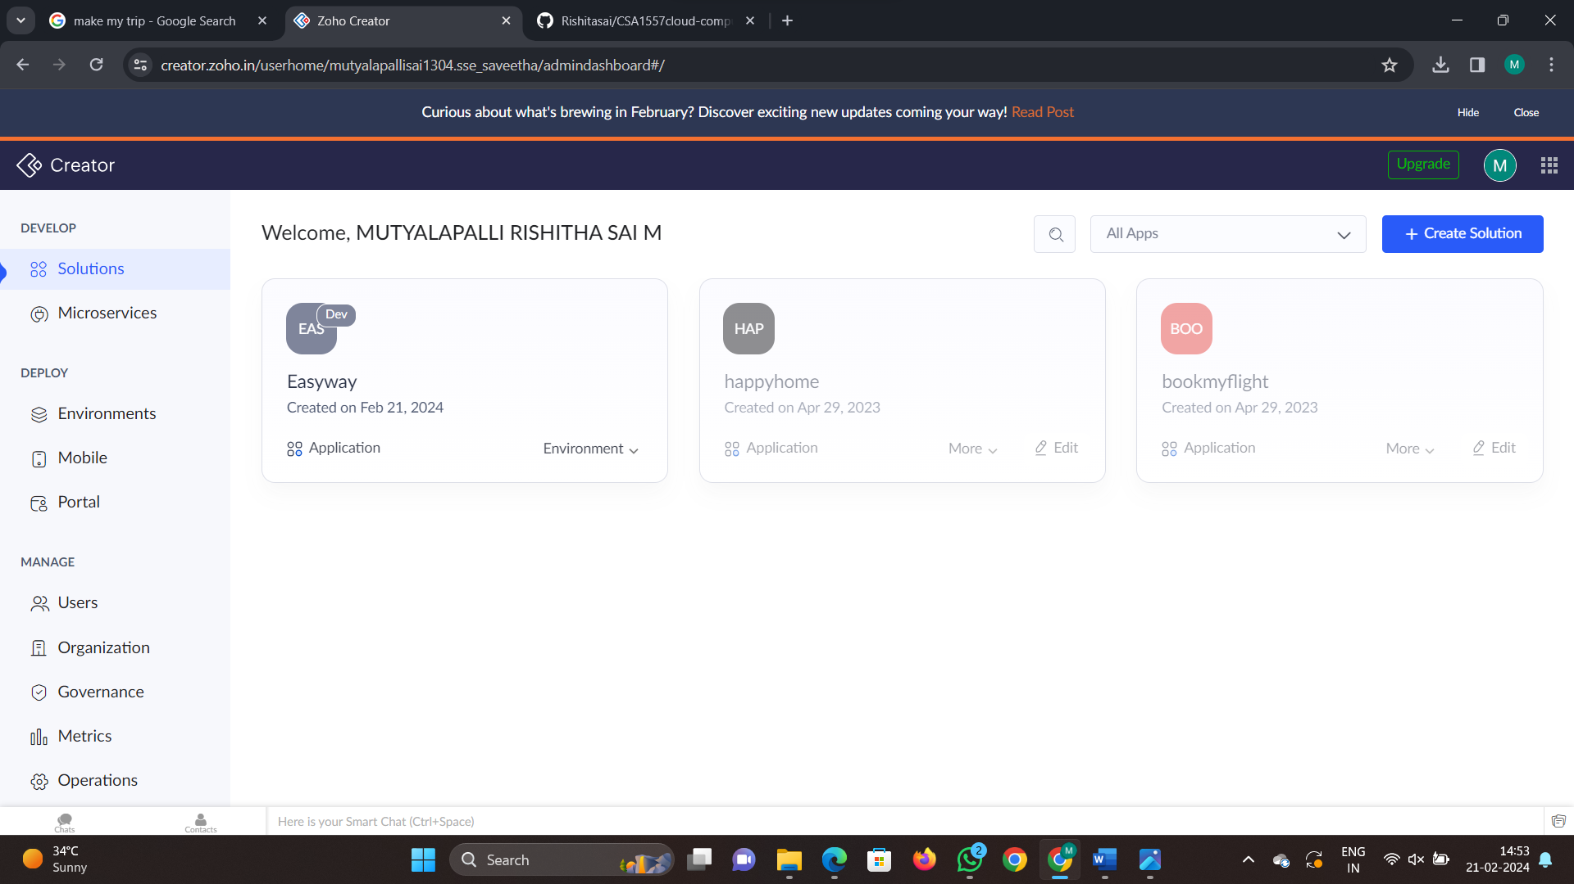

Step2: Now create a form and name it as details and select a template from the gallery which is cab booking and enter details

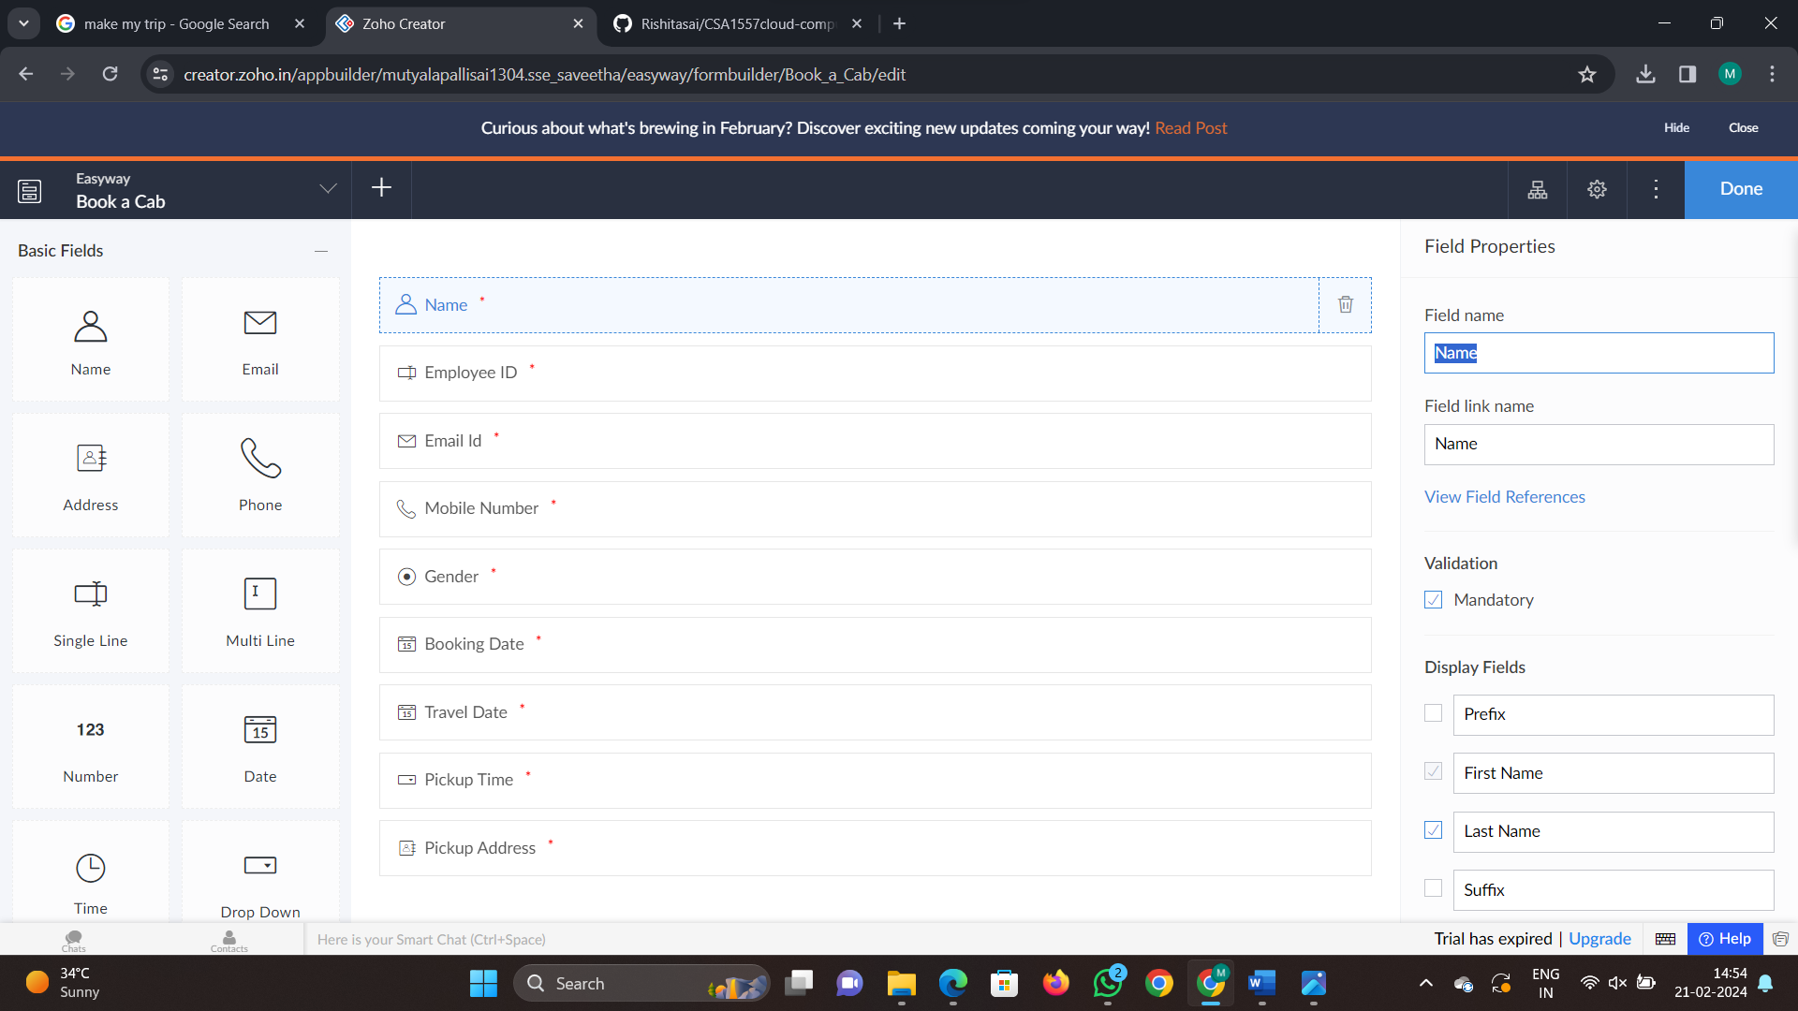

Step 3: Now click done and click on plus to add another form and name it as payments

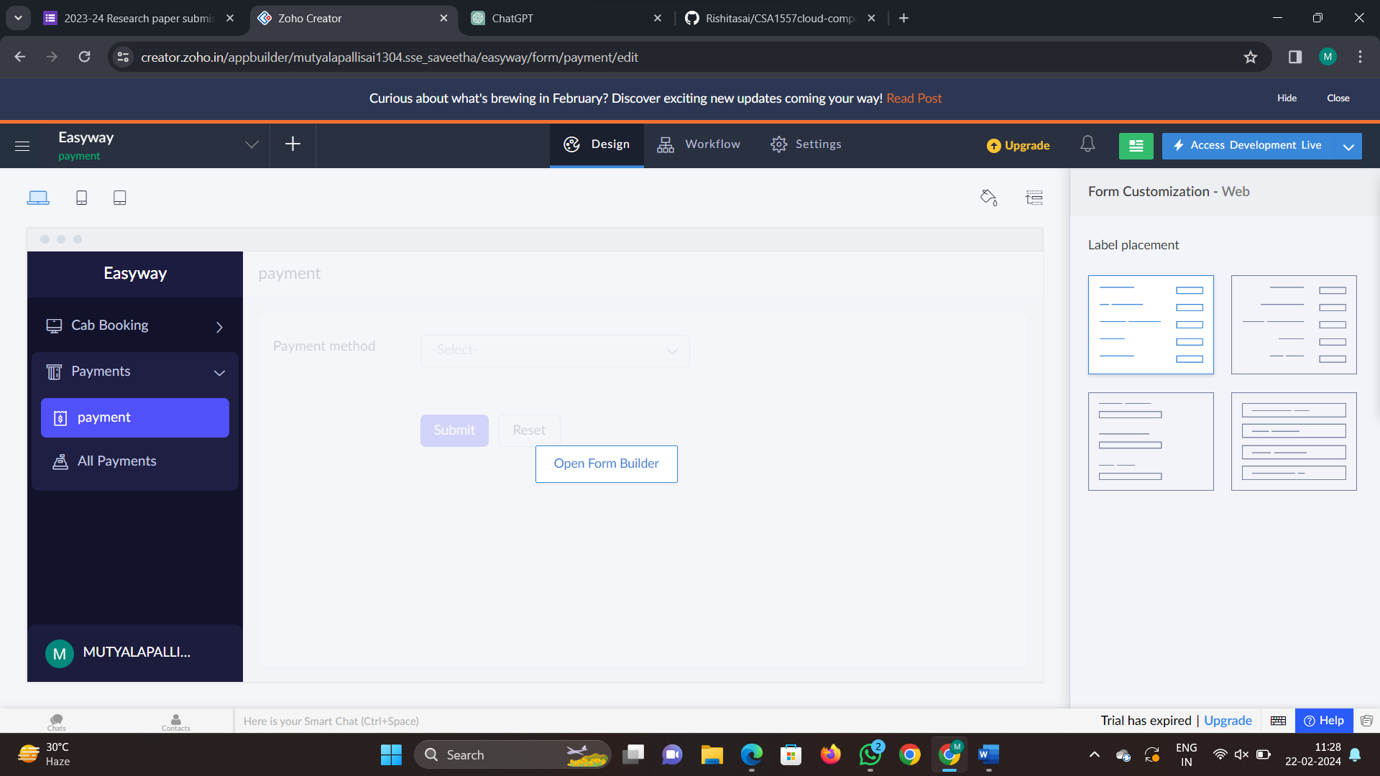

Step 4: Now press add another form and booked cab details and fill the form

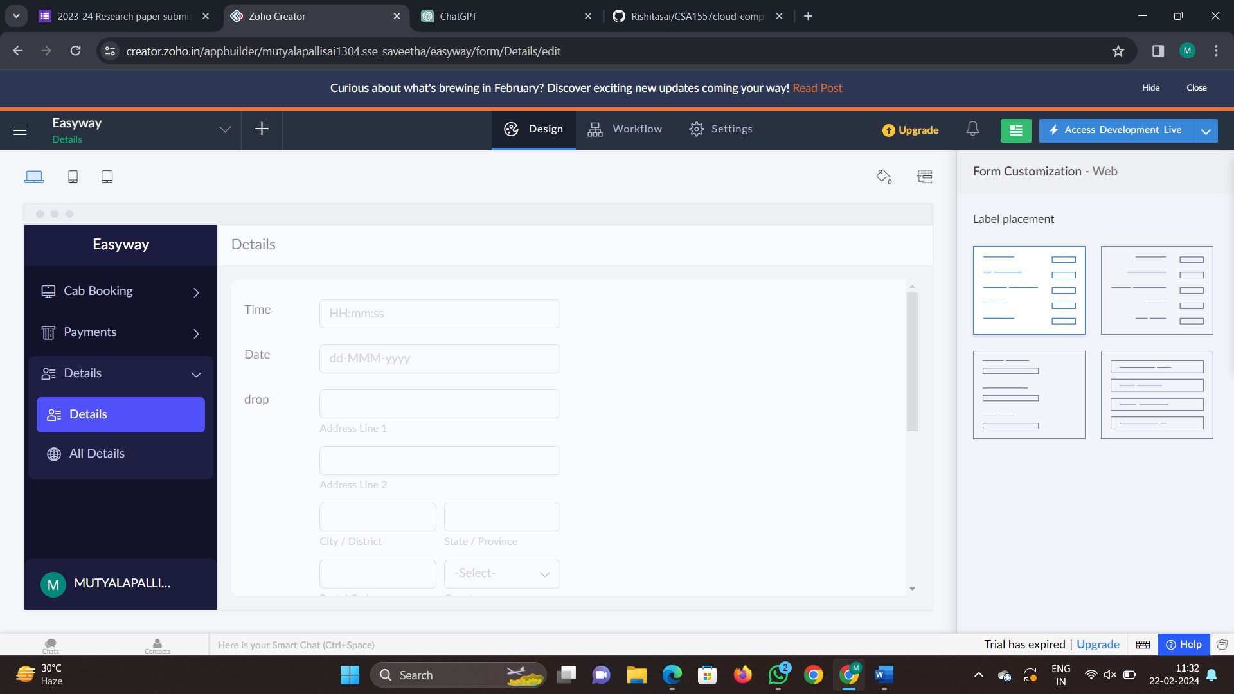

Step 5: now click access development live

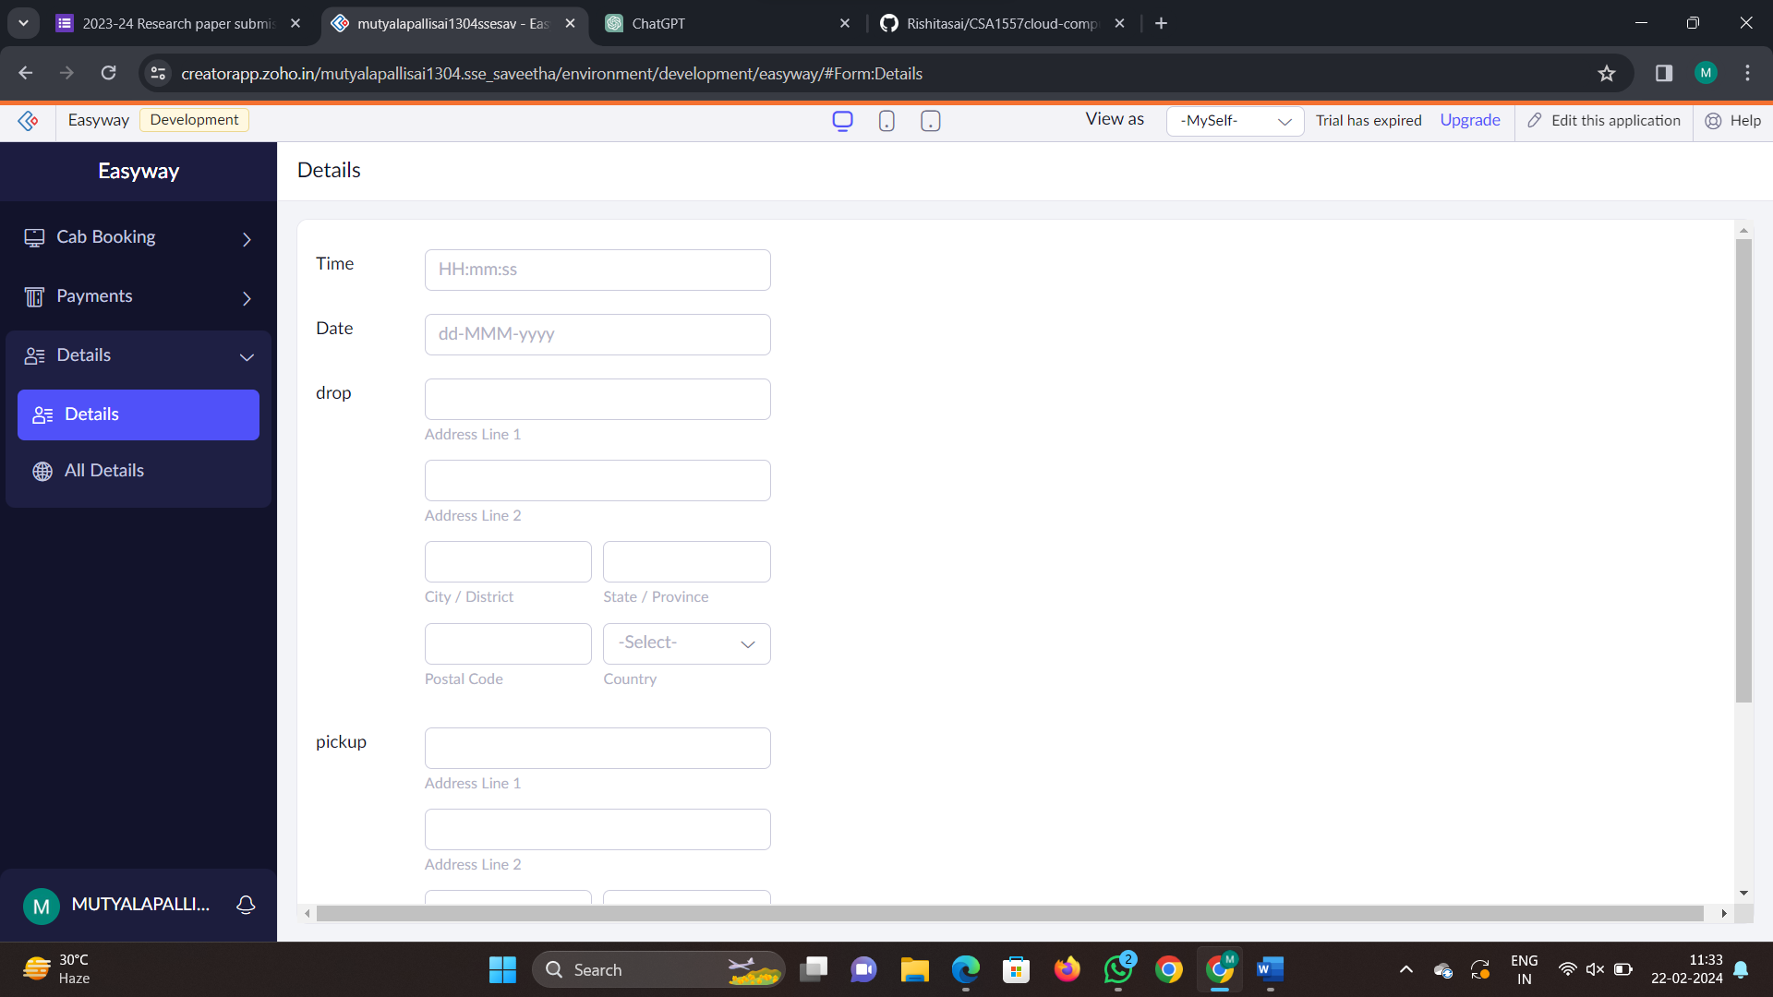

Step 6: Now fill the fields and submit the form and Now the report is created

